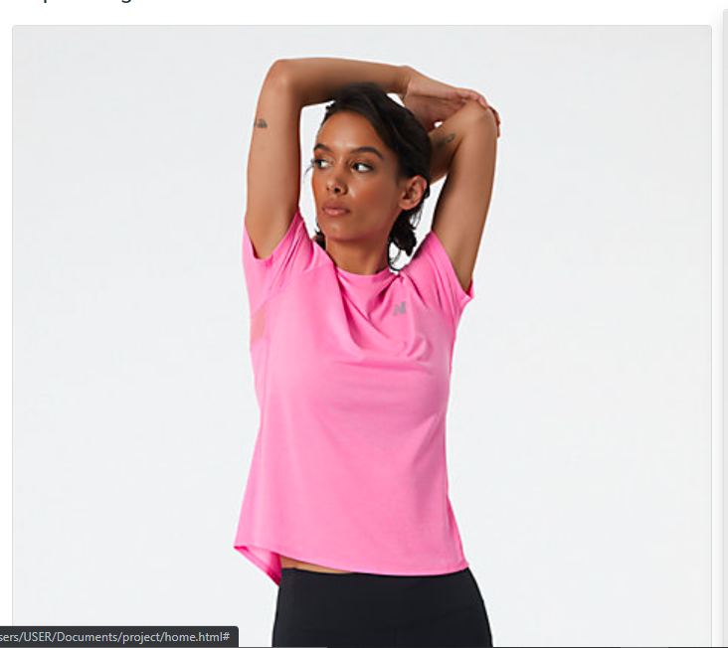

Nike Pro 365

The easiest way of approaching this is to think about the info you’d look for if you were browsing a similar campaign. Ideally, you should include:

* **Brief info** on you or your organization.
* **Design inspiration**
* **Summary of your cause** if you’re raising money and awareness for one
* **Any selling points on the garment** itself that you feel are worth mentioning

Whether you’re an individual seller or a charity, organization or collective, we’ve outlined how to make sure you’re covering these in just a few sentences with examples below: